Practical File
of

Fundamentals of C Programming
(24CSE0107)

Batch-2025

Bachelor of Engineering (CSE)



Submitted By  Maulik Sharma  Roll No.2510990907  Group No., Sem: 2nd, BE (CSE)  Chitkara University, Punjab, 140401  India | Submitted To  Dr. Gaganpreet Kaur  Designation, CSE  Chitkara University, Punjab, 140401  India

Department of
Computer Science and Engineering,
Chitkara University School of Engineering and Technology,
Chitkara University, Punjab, India
Index
Sr. No. | Experiment | Page No.
1 | Discussion on uploading and managing C Programming Lab  Practical on GitHub using GitBash/CMD.
2 | Install C compiler (GCC/Code::Blocks), set up IDE, compile and run the first 'Hello, World!' program.
3 | Write a program to show the use of input (scanf), output (printf) statements and block structure of C program highlighting the features of stdio.h.
4 | Write a program to add two numbers and display the sum.
5 | Write a program to calculate the area and the circumference of a  circle by using radius as the input provided by the user.
6 | Write a program to perform addition, subtraction, division and multiplication of two numbers given as input by the user.
7 | Write a program to evaluate each of the following equations.  (i) V = u + at. (ii) S = ut+1/2at 2 (iii) T=2*a+√b+9c (iv) H=√b 2 +p 2
8 | Write a program to swap two variables using temporary variable and without temporary variable.
9 | Write a Program to find the greatest among three numbers using:  - Conditional Operator  - If-Else statement
10 | Write the following programs using switch case statement:  - To check that an input alphabet is vowel or consonant  - To check whether a number is positive, negative or zero
11 | Write a program using while loop to print the sum of first n natural numbers.
12 | Write a program to check a number is Armstrong or not using for loop.
13 | Write the program to count the digits in a number and then print the  reverse of the number also.
14 | Write a program to generate the Fibonacci series.
15 | Write a program to print the following patterns:
16 | Write the program to print the following pattern:
17 | Write a program to perform the following operations on 1D-Array:
18 | Write a program to calculate the sum of array elements by passing it  to a function.
19 | Write a program matrix multiplication using the concept of 2D array
20 | Write a program to transpose a given matrix.
21
22
23
24
25
26
27
28
29
30
31

Experiment No. 1.

Aim: To learn how to upload, organize, and manage C programming lab practical files using Git and GitHub through Git Bash or Command Prompt (CMD).

Concept Used:
• Version control system: Git
• Online repository hosting platform: GitHub
• Git commands: git init, git add, git commit, git push, git clone
• Command line tools: Git Bash / Command Prompt
• Repository management and file tracking
Program:
# Navigate to your C practical folder
cd path/to/your/C_Lab_Practicals
# Initialize git repository
git init
# Add all files to staging area
git add .
# Commit files
git commit -m "Added C programming lab practicals"
# Connect to GitHub repository (replace URL with your repo link)
git remote add origin https://github.com/username/repository-name.git
# Push files to GitHub
git branch -M main
git push -u origin main

Output Screenshot:
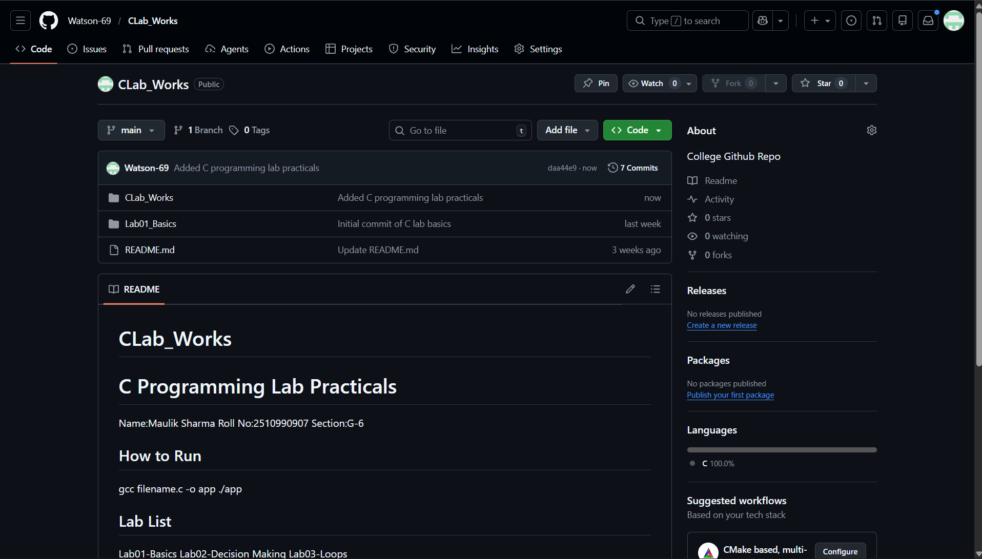

Experiment No. 2.
Aim: Install C compiler (GCC/Code::Blocks), set up IDE, compile and run the first 'Hello, World!' program.
Concept Used:
• Header file: stdio.h
• Function used: printf()
• Structure of C program: main() function
• Compilation and execution process
Program:
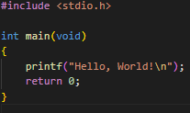

Output Screenshot:
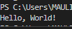

Experiment No. 3.

Aim: Write a program to show the use of input (scanf), output (printf) statements and block structure of C program highlighting the features of stdio.h.

Concept Used:
• Header file: stdio.h
• Functions used: printf(), scanf()
• Variables and data types
• Block structure of C program
Program:
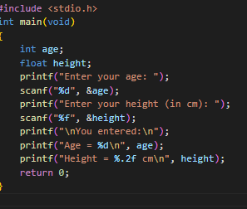

Output Screenshot:
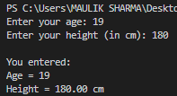
Experiment No. 4.

Aim: Write a program to add two numbers and display the sum.

Concept Used:
• Header file: stdio.h
• Functions: scanf(), printf()
• Arithmetic operator: +
• Variables and data types
Program:
#include <stdio.h>
int main(void)
{
double a, b;
printf("Enter two numbers: ");
scanf("%lf %lf", &a, &b);
printf("Sum = %.2f\n", a + b);
return 0;
}
Output Screenshot:
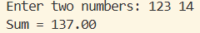

Experiment No. 5.

Aim: Write a program to calculate the area and the circumference of a circle by using radius as the input provided by the user.

Concept Used:
• Header file: stdio.h, math.h (optional)
• Functions: scanf(), printf()
• Arithmetic operators: *, +
• Floating point variables
Program:
#include <stdio.h>
int main(void)
{
double r;
const double pi = 3.141592653589793;
printf("Enter radius: ");
scanf("%lf", &r);
printf("Area = %.2f\n", pi * r * r);
printf("Circumference = %.2f\n", 2 * pi * r);
return 0;
}

Output Screenshot:
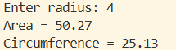
Experiment No. 6.

Aim: Write a program to perform addition, subtraction, division and multiplication of two numbers given as input by the user.

Concept Used:
• Header file: stdio.h
• Functions: scanf(), printf()
• Arithmetic operators: +, -, *, /
• Operator precedence

Program:
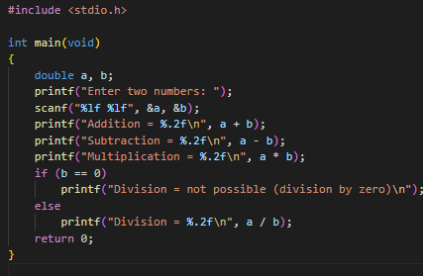

Output Screenshot:
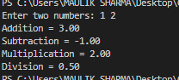

Experiment No. 7.

Aim: Write a program to evaluate each of the following equations.
(i) V = u + at. (ii) S = ut+1/2at 2 (iii) T=2*a+√b+9c (iv) H=√b 2 +p 2

Concept Used:
• Header file: stdio.h, math.h
• Functions: scanf(), printf(), sqrt()
• Arithmetic operators
• Mathematical expressions

Program:

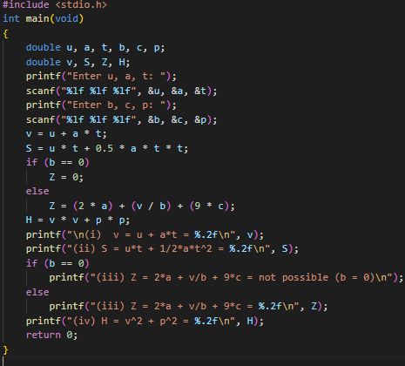
Output Screenshot:
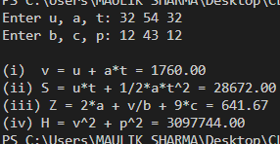
Experiment No. 8.

Aim: Write a program to swap two variables using temporary variable and without temporary variable.

Concept Used:
• Header file: stdio.h
• Functions: scanf(), printf()
• Temporary variable method
• Arithmetic swapping logic
Program:
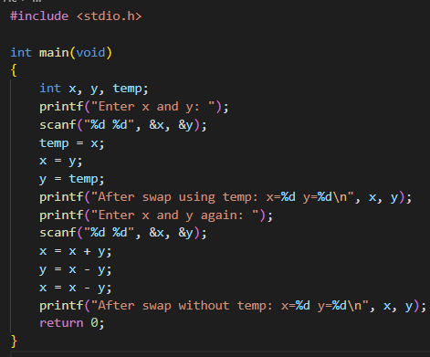

Output Screenshot:
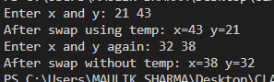
Experiment No. 9.

Aim: Write a Program to find the greatest among three numbers using:
- Conditional Operator
- If-Else statement

Concept Used:
• Header file: stdio.h
• Functions: scanf(), printf()
• Conditional operator (?:)
• if-else statement
• Relational operators
Program:
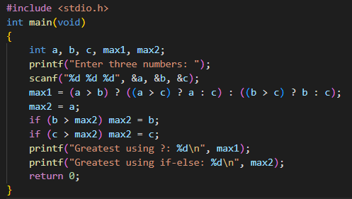

Output Screenshot:
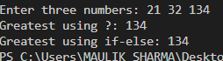

Experiment No. 10.

Aim: Write a Program to find the greatest among three numbers using:
- Conditional Operator
- If-Else statement

Concept Used:
• Header file: stdio.h
• Functions: scanf(), printf()
• switch case statement
• break statement
Program:
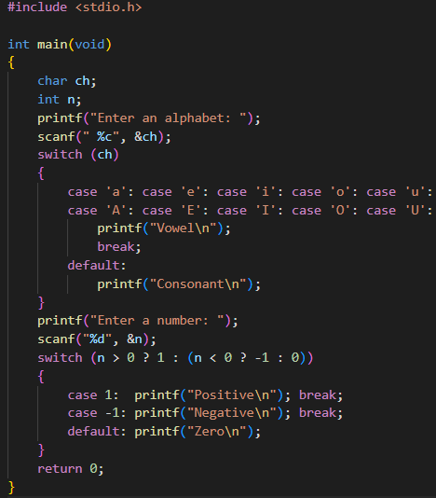

Output Screenshot:
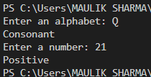

Experiment No. 11.

Aim: Write a program using while loop to print the sum of first n natural numbers.

Concept Used:
• Header file: stdio.h
• Functions: scanf(), printf()
• while loop
• Loop control variable
Program:
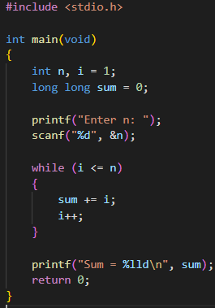

Output Screenshot:
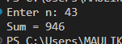

Experiment No. 12.

Aim: Write a program to check a number is Armstrong or not using for loop.

Concept Used:
• Header file: stdio.h
• Functions: scanf(), printf()
• for loop
• Modulus operator (%)
• Power logic

Program:
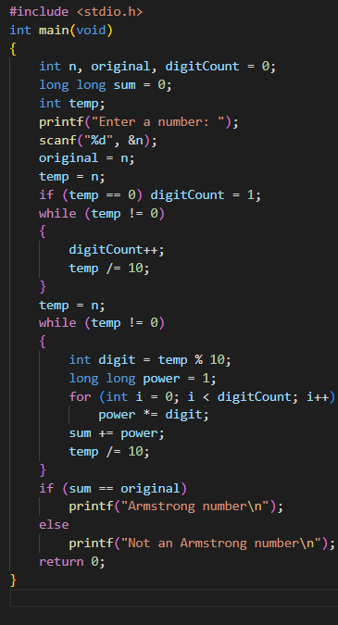

Output Screenshot:
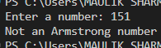
Experiment No. 13.

Aim: Write the program to count the digits in a number and then print the reverse of the number also.

Concept Used:
• Header file: stdio.h
• Functions: scanf(), printf()
• while loop
• Modulus and division operators

Program:
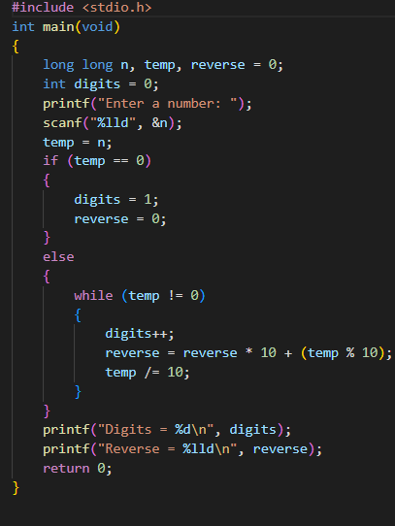
Output Screenshot:
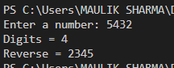

Experiment No. 14.

Aim: Write a program to generate the Fibonacci series.

Concept Used:
• Header file: stdio.h
• Functions: printf()
• Loop (for / while)
• Sequence generation
Program:
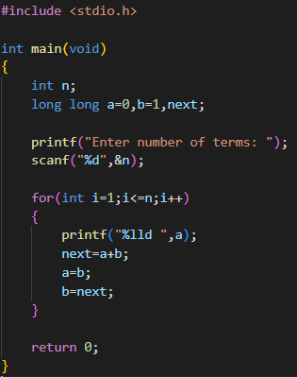

Output Screenshot:
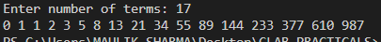

Experiment No. 15.

Aim: Write a program to print the following patterns:
a)
*
* *
* * *
* * * *
* * * * *
* * * * * *
b)
*
* *
* * *
* * * *
* * * * *
* * * * * *

Concept Used:
• Header file: stdio.h
• Nested loops
Program:
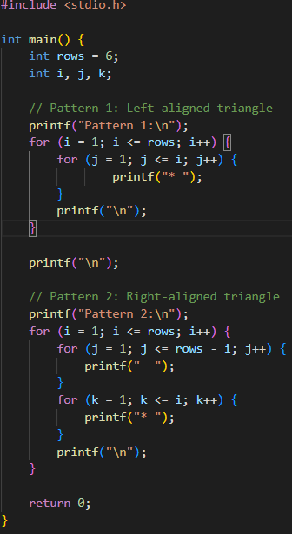

Output Screenshot:
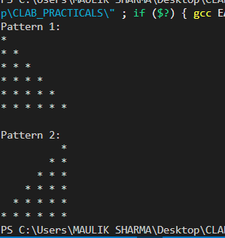

Experiment No. 16.

Aim: Write the program to print the following pattern:

1 2 3 4 5 6
2 4 6 8 10 12
3 6 9 12 15 18
4 8 12 16 20 24
5 10 15 20 25 30
6 12 18 24 30 36
Concept Used:
• Header file: stdio.h
• Nested loops
Program:
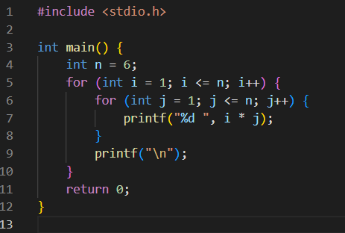

Output Screenshot:
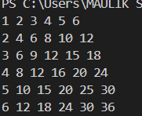

Experiment No. 17.

Aim: Write a program to perform the following operations on 1D-Array:
- Insert
- Update
- Delete
- Display
- Search
Concept Used:
•Arrays
•Looping
•Switch case
• Searching
Program:

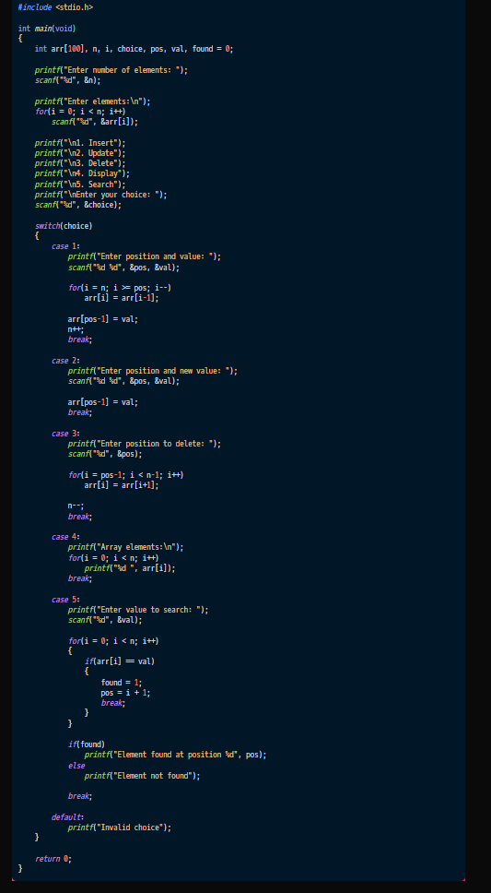

Output Screenshot:
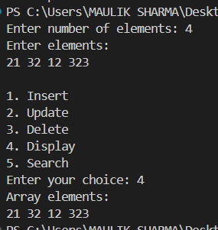

Experiment No. 18.

Aim: Write a program to calculate the sum of array elements by passing it to a function.
Concept Used:
•Arrays
•Looping
• Functions
• Parameter passing
Program:
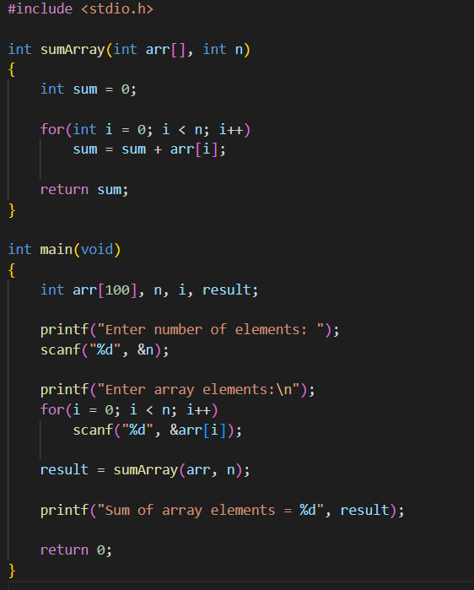

Output Screenshot:
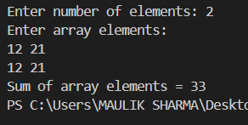

Experiment No. 19.

Aim: Write a program for matrix multiplication using the concept of 2-D array.
Concept Used:
•2-D Arrays
•Nested Looping
Program:
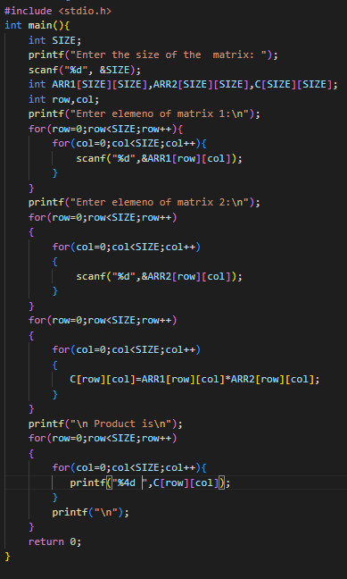
Output Screenshot:
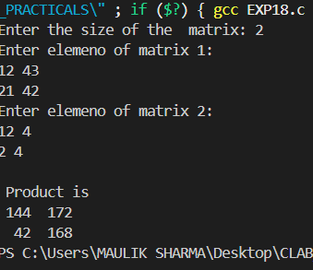

Experiment No. 20–.

Aim: Write a program to transpose a given matrix.
Concept Used:
•2-D Arrays
• Matrix transpose logic
Program:
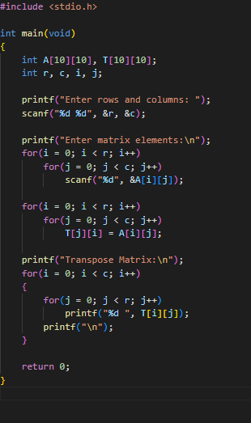

Output Screenshot:
